|  |  |
| --- | --- |
| **Soal Praktikum**  *Practicum Case* |  |
| ISYS6169 /T0206  Database Systems |
| **Sistem Informasi**  *Information System* | **E1-ISYS6169-AM01** |
| **Periode Berlaku** Semester Ganjil 2016/2017  ***Valid on*** *Odd Semester Year 2016/2017* | **Revisi 00**  *Revision 00* |

**Learning Outcomes**

* Apply database language and SQL Programming language

## Topic

* Session 02 **-** SQL – Data Definition (1)

## Sub Topics

* Introducing table and referential integrity
* Primary and Foreign Key
* Constraint Value
* Drop Table
* Alter Table

**Tabel Relasional**

*Relational Table*

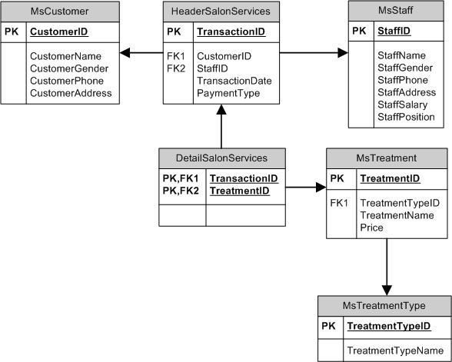

**Sintaks**

*Syntax*

**Create Table**

CREATE TABLE **table_name**

(

field1_name datatype ( length ) [NOT NULL]

, field2_name datatype ( length ) [NOT NULL]

, field3_name datatype ( length ) [NOT NULL]

[ , … ]

[ , PRIMARY KEY ( field_name [, …] ) ]

[ , FOREIGN KEY ( field_name ) REFERENCES **table_name** ( field_name )]

[ , CONSTRAINT constraint_name CHECK (criteria) ]

)

**Drop Table**

DROP TABLE **table_name**

**Alter Table**

ALTER TABLE **table_name**

{ ADD column_name datatype |

DROP COLUMN column_name |

ALTER COLUMN column_name datatype |

ADD CONSTRAINT constraint_name CHECK(criteria) |

ADD PRIMARY KEY (primary_key_name) |

DROP CONSTRAINT constraint_name }

## Soal

*Case*

1. Create tables with the following descriptions :

(**create table**, **like**)

Table’s Name: **MsCustomer**

Primary Key : **CustomerId**

|  |  |  |  |
| --- | --- | --- | --- |
| **Field Name** | **Data Type** | **Length** | **Description** |
| CustomerId | CHAR | 5 | Cannot be empty, must be started with ‘CU’ and followed by 3 characters of number.  Example: CU001 |
| CustomerName | VARCHAR | 50 | - |
| CustomerGender | VARCHAR | 10 | Must be ‘Male’ or ‘Female’ |
| CustomerPhone | VARCHAR | 13 | - |
| CustomerAddress | VARCHAR | 100 | - |

Table’s Name: **MsStaff**

Primary Key : **StaffId**

|  |  |  |  |
| --- | --- | --- | --- |
| **Field Name** | **Data Type** | **Length** | **Description** |
| StaffId | CHAR | 5 | Cannot be empty, must be started with ‘SF’ and followed by 3 characters of number.  Example: SF001 |
| StaffName | VARCHAR | 50 | - |
| StaffGender | VARCHAR | 10 | Must be ‘Male’ or ‘Female’ |
| StaffPhone | VARCHAR | 13 | - |
| StaffAddress | VARCHAR | 100 | - |
| StaffSalary | NUMERIC | 11,2 | - |
| StaffPosition | VARCHAR | 20 | - |

Table’s Name: **MsTreatmentType**

Primary Key : **TreatmentTypeId**

|  |  |  |  |
| --- | --- | --- | --- |
| **Field Name** | **Data Type** | **Length** | **Description** |
| TreatmentTypeId | CHAR | 5 | Cannot be empty, must be started with ‘TT’ and followed by 3 characters of number.  Example: TT001 |
| TreatmentTypeName | VARCHAR | 50 | - |

Table’s Name: **MsTreatment**

Primary Key : **TreatmentId**

|  |  |  |  |
| --- | --- | --- | --- |
| **Field Name** | **Data Type** | **Length** | **Description** |
| TreatmentId | CHAR | 5 | Cannot be empty, must be started with ‘TM’ and followed by 3 characters of number.  Example: TM001 |
| TreatmentTypeId | CHAR | 5 | Cannot be empty, references from **MsTreatmentType** and if the referenced data is changed then the TreatmentTypeId data in **MsTreatment** will also be changed |
| TreamentName | VARCHAR | 50 | - |
| Price | NUMERIC | 11,2 | - |

Table’s Name: **HeaderSalonServices**

Primary Key : **TransactionId**

|  |  |  |  |
| --- | --- | --- | --- |
| **Field Name** | **Data Type** | **Length** | **Description** |
| TransactionId | CHAR | 5 | Cannot be empty, must be started with ‘TR’ and followed by 3 characters of number.  Example: TR001 |
| CustomerId | CHAR | 5 | Cannot be empty, references from **MsCustomer** and if the referenced data is changed then the CustomerId data in **HeaderSalonServices** will also be changed |
| StaffId | CHAR | 5 | Cannot be empty, references from **MsStaff** and if the referenced data is changed then the StaffId data in **HeaderSalonServices** will also be changed |
| TransactionDate | DATE | - | - |
| PaymentType | VARCHAR | 20 | - |

Table’s Name: **DetailSalonServices**

Primary Key : TransactionId, TreatmentId

|  |  |  |  |
| --- | --- | --- | --- |
| **Field Name** | **Data Type** | **Length** | **Description** |
| TransactionId | CHAR | 5 | Cannot be empty, references from **HeaderSalonServices** and if the referenced data is changed then the TransactionId data in **DetailSalonServices** will also be changed |
| TreatmentId | CHAR | 5 | Cannot be empty, references from **MsTreatment** and if the referenced data is changed then the TreatmentId data in **DetailSalonServices** will also be changed |

1. Delete the **DetailSalonServices** table.

(**drop table**)

1. Create tables with the following descriptions :

Table’s Name: **DetailSalonServices**

|  |  |  |  |
| --- | --- | --- | --- |
| **Field Name** | **Data Type** | **Length** | **Description** |
| TransactionId | CHAR | 5 | Cannot be empty, references from **HeaderSalonServices** and if the referenced data is changed then the TransactionId data in **DetailSalonServices** will also be changed |
| TreatmentId | CHAR | 5 | Cannot be empty, references from **MsTreatment** and if the referenced data is changed then the TreatmentId data in **DetailSalonServices** will also be changed |

Then, with **alter** syntax, change the TransactionId and TreatmentId field to become primary key on that table.

(**create table**, **alter table**, **primary key**)

1. Add a constraint for **MsStaff** table to validate that staff’s name must be between 5 and 20 characters and the previous data is not necessary to be checked. Then, delete the constraint.

**(alter table**, **with nocheck**, **add constraint**, **drop)**

1. Add ‘Description’ as a new column on **MsTreatment** table with varchar(100) data type. Then, delete the column.

**(alter table**, **add**, **drop column)**